THE CLEVELAND CARAMEL CORN CO.
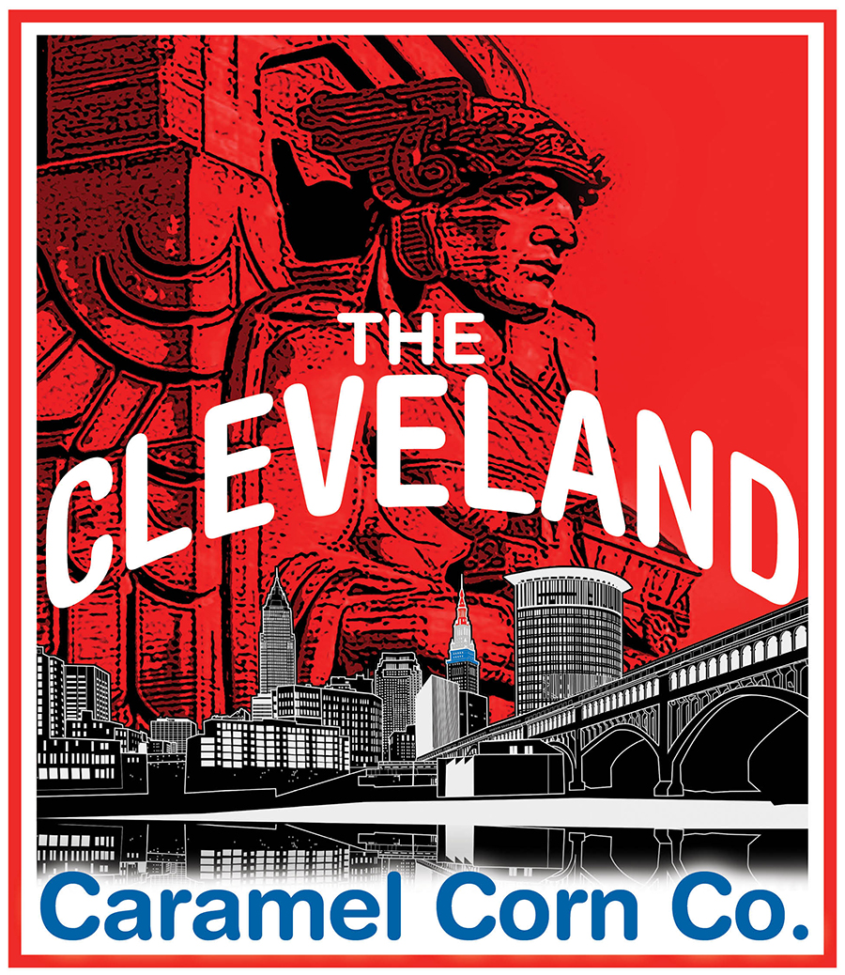
For additional information please contact us at (440) 846-1727 or via email at info@theclecaramelcornco.com

~ MASTER FUNDRAISING ORDER FORM~

ORGANIZATION INFORMATION: | COORDINATOR:
NAME: | EMAIL:
ADDRESS: | CONTACT NUMBER:
CITY: | CONTACT PREFERENCE:
STATE, ZIP: | NOTES:

ORDER: | CAMPAIGN START DATE:
# OF CARAMEL CORN BAGS ORDERED: | # OF HOT CHEESE BAGS ORDERED:
# OF CHEDDAR/CARAMEL BAGS ORDERED: | # OF WHITE CHEDDAR BAGS ORDERED:
# OF CHEDDAR CHEESE BAGS ORDERED: | # OF TACO POPCORN BAGS ORDERED:
TOTAL # OF BAGS ORDERED X $4: | CAMPAIGN END DATE:
*REQUESTED POPCORN READY DATE:  *WE WILL DO OUR BEST TO ACCOMODATE YOUR REQUEST* | PAYMENT METHOD:
DELIVERY/PICKUP PREFERENCE: | INTERNAL USE ONLY:
NOTES:

ON BEHALF OF THE ORGANIZATION LISTED ABOVE, I AGREE THIS ORDER IS ACCURATE AND AGREE TO PAY THE BALANCE DUE. I UNDERSTAND THAT THE BALANCE MUST BE PAID IN FULL BEFORE THE DELIVERY/PICKUP OF OUR ORDER CAN OCCUR.

SIGNATURE OF COORDINATOR
(INTERNAL USE ONLY) BALANCE PAID IN FULL? YES / NO - DATE: / /

